How to Setup Emerald Mass Programmer

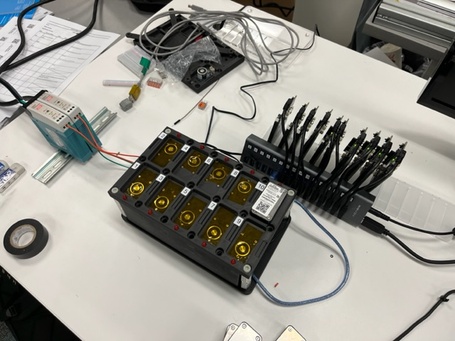

1. Connect the 2 green wires to the positive terminal of the two 5V, 3A power supplies and the 2 orange wires to the negative terminal of the two 5V, 3A power supplies.
2. Plug in the 12V,2A barrel jack to an outlet then plug into the Arduino.
3. Power the two 5V, 3A power supply by plugging them into outlets.
4. Setup the 16 Port USB HUB by powering it up using an outlet then connect the USB Type B to the laptop.
5. Plug the 10 Nordic NRF52-DKs to Ports 1-10 on the 16 Port USB HUB and the Arduino USB to Port 11. Please carefully place the Nordic NRF52-DK into the slotted fixture as shown in the picture above (fixture is fragile).
6. Go to device manager on the laptop and note down the COM Ports for the Arduino UNO and the 10 NRF52-DKs



1. In line 105 of the TrkMassProg2/TrkMassProg2_Final_FW fill the list with the 10 COM Ports the NRF52-DKs are connected to



1. Set the Ser Port to the COM Port of the Arduino in Line 161 on TrkMassProg2_Final_FW.py and Line 163 in TrkMassProg2.py

How to Use Emerald Mass Programmer

1. Get the required scripts for the Mass Programmer by launching git bash then entering “ git clone <https://github.com/Trackonomy/Emerald_Mass_Programmer.git> “
2. If you want to program final fw, do “ git checkout final_fw “
3. Then load the Arduino program from the file to the board by launching it then pressing upload.
4. Make sure all the NRF52-DKs are showing up in the COM ports by checking device manager (should be 10).
5. Scan the dominos then place them upside down in the pockets.
6. Now run execute the Mass Programmer.bat file by double clicking it.
7. All 10 LEDs turning on indicates the magnets are on.